**SOP**

***for Setting of Switch***

|  |  |  |  |
| --- | --- | --- | --- |
|  | **Created By** | **Reviewed By** | **Approved By** |
| **Name** |  |  |  |
| **Designation** |  |  |  |
| **Organization** |  |  |  |
| **Signature** |  |  |  |
| **Date** |  |  |  |

# SOP for Setting of TP-Link Switch SG3210

## General Settings

1. Kindly go to Virdi device Settings as mentioned above.
2. Based on the network settings of the Virdi Device, kindly put up the gateway IP in the Google Chrome URL, and check if it opens the Switch Webpage.
3. If no, kindly change IP address to the previous or next IP address as that of Virdi device, till the web page of the TP Link switch is opened.
4. In SD WAN, LAN switch needs to have IP address for first time configuration for Godrej HO team to cross verify.
5. This setting can be removed by BPCL from SD WAN, after intimation from Godrej team.

## User Settings

1. Once Switch Web Page is opened, kindly Login into the switch using default credentials.

Login: **admin**

Password: **admin**

1. Once logged in, there will be a menu popped up to change the default password.
2. Kindly change the default Admin password to a strong password consisting of Uppercase and Lowercase alphabets, numbers and a special key.
3. The password can also be changed later by entering System.

1. Then to User Management

1. Check on Password Modify, so that the three fields below will get enabled.
2. Then enter the current password, new password and then confirm new password as per the Strong password policy. Then click on Save.
3. The new password for login page will then get saved.

## Security Management

1. To impose the restriction on no. of Admin users, kindly go to Security.

1. Enable the Number Control.
2. Enter the Number of Operators to 1, so that only one Admin is created and can login to the System Settings. Click on Apply.
3. Also set the Session Timeout to be 5 Seconds. Click on Apply.

## A screenshot of a computer Description automatically generatedPort Hardening

1. Kindly enter L2 Features.
2. In switching, click on Port Config
3. Kindly Go to UNIT1
4. Select the physical ports which are not connected by selecting the checkboxes.
5. Kindly set the status as **Disabled.** Click on Apply.
6. This will disable all the open physical ports which are unused.

## MAC ID Binding

1. 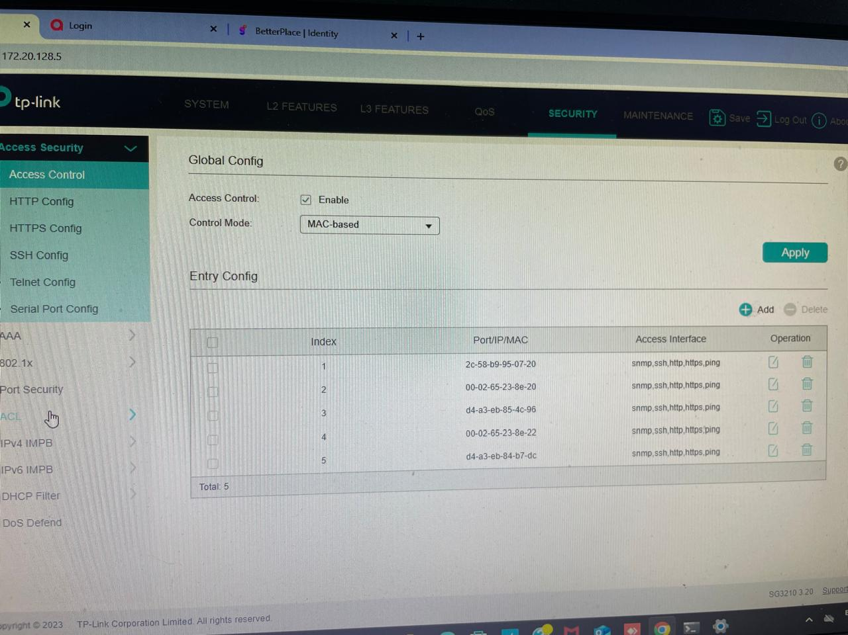Click on Security.
2. In Access Security, click on Access Control
3. In Global Config, Enable the Access Control
4. Select Control Mode to “MAC based”
5. Click on Add and kindly select all the protocols other than TELNET.
6. Then enter the respective MAC ID
7. Repeat the above process for the MAC IDs of all the Virdi devices as well as PC connected to TP Link Switch.
8. Click on Apply.

## A computer screen with a computer screen Description automatically generatedHTTP Configuration

1. Click on Security.
2. In Access Security, click on HTTP Config
3. Select HTTP Enable checkbox. Click Apply.
4. Set Session Timeout to minimum of 5 minutes. Click Apply.
5. Enable Number Control checkbox.
6. Set Number of Admins to 1. Then click Apply.

## A computer screen shot of a computer Description automatically generatedHTTPS Configuration

1. Click on Security.
2. In Access Security, click on HTTPS Config
3. Select HTTPS Enable checkbox. Click Apply.
4. In Session Config, set Session Timeout to minimum of 5 minutes. Click Apply.

## SSH Configuration

1. Click on Security.
2. In Access Security, click on SSH Config
3. Select SSH Enable checkbox. Click Apply.
4. Set Session Timeout to 360 seconds.

## DoS Protection

1. Click on Security.
2. Click on DoS Defend. Click Apply.
3. Enable all the checkboxes in DoS Defend Config. Click Apply.